
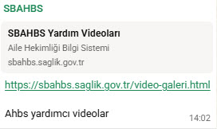
- https://sbahbs.saglik.gov.tr/video-galeri.html
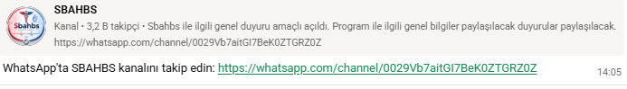
- https://whatsapp.com/channel/0029Vb7aitGI7BeK0ZTGRZ0Z
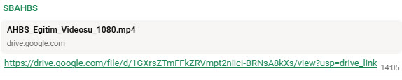
- https://drive.google.com/file/d/1GXrsZTmFFkZRVmpt2niicI-BRNsA8kXs/view?usp=drive_link
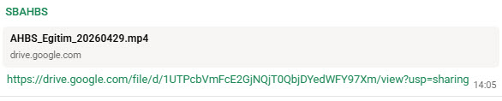
- https://drive.google.com/file/d/1UTPcbVmFcE2GjNQjT0QbjDYedWFY97Xm/view?usp=sharing
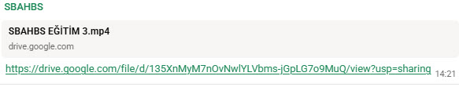
- https://drive.google.com/file/d/135XnMyM7nOvNwlYLVbms-jGpLG7o9MuQ/view?usp=sharing

